# Datasource Indexer

User Manual

Contents

Datasource Indexer 1

Introduction 2

References 2

Installation 2

Usage 2

To know 3

## Introduction

This document describes how to use the Datasource Indexer Modules. It gives information to how to install the modules and how to use it.

The modules provides you a way to index your Datasource item by adding them on the _content field of the referred item.

## References

Blog, projects, persons that help during the development of the module.

Content Usage Tool : <https://github.com/team-orange/sitecore-content-usage-tools>

Techopria414 : <http://www.techphoria414.com/Blog/2013/November/Sitecore-7-Computed-Fields-All-Templates-and-Datasource-Content>

Jeremy Coste, for the brainstorming and the idea

Robin Hermanussen: <http://hermanussen.eu/sitecore/wordpress> , for his help during the development (**z**DatasourceIndexer.config !!)

## Installation

Simply install the packages via the Sitecore Installation Wizard.

## Usage

To define how to index a datasource, a new section is added on each sublayout. Some fields are dependent of the Datasource Template of the Sublayout.

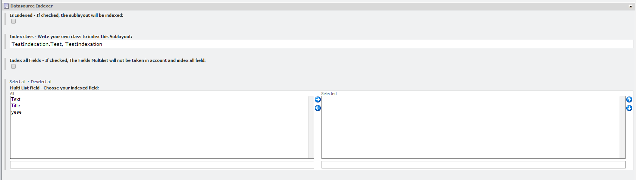

The new section (Datasource Indexer) is composed by:

* Is Indexed : If the checkbox is check, he will index the sublayout datasource.
* Index Class: If you have some custom field that you want to index, or index a different way, you can create a class which inherit from DatasourceComputed and override the method string Run(Item),then simply add the Namespace, and the assembly in the single line text.
* Index All Field: If this checkbox is checked, you will index all the field of the datasource template set on the sublayout.
* Multi List Field: Choose which field to index, take care that if you use that multi list, index all field should not be checked.

When you save a datasource item, he will trigger the GetDependencies pipelines which will reindex the page referred to the datasource.

## To know

The module write the result of his indexation into the _content field, I let the default behavior of MediaItemContentExtractor, if he matches a media Item I did not understand all the class but I think he only treat the MediaItem (this is how I made the difference between treated my items, and other items)

This module has his limitation and are the following:

* You cannot specify for each Rendering which field to index (Maybe in a future version)
* There will be a problem if you play with the Devices …
* If you play with the BasePage on the Datasource Template, he will not fetch all the field of a more complex datasource.